SOUTHERN CALIFORNIA OLDSMOBILE CLUB EVENT
Rick Lorenzen’s AUTOMOBILIA Car Collection
Saturday, November 14th 9:00am to 12:00pm
At “PRICE TRANSFER”
2790 Del Amo Blvd., Rancho Dominguez
(710 Fwy @ E. Del Amo Blvd.)
Follow the signs for off-street parking!
Lots of showrooms and automobiles!
Talk to the Crew!! Bring your Oldsmobile!!
Lunch will follow at TBA location!!
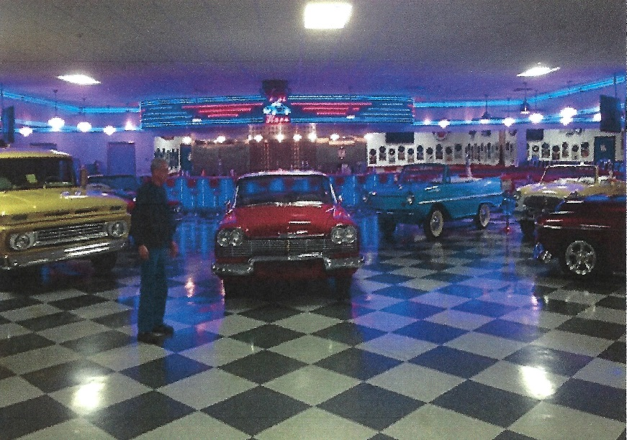
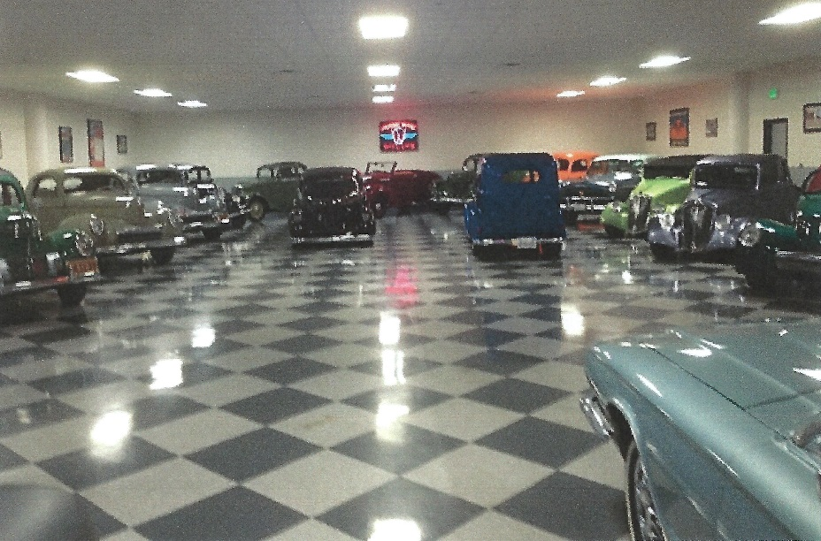

SOUTHERN CALIFORNIA OLDSMOBILE CLUB EVENT
Rick Lorenzen’s AUTOMOBILIA Car Collection
Saturday, November 14th 9:00am to 12:00pm
At “PRICE TRANSFER”
2790 Del Amo Blvd., Rancho Dominguez
(710 Fwy @ E. Del Amo Blvd.)
Follow the signs for off-street parking!
Lots of showrooms and automobiles!
Talk to the Crew!! Bring your Oldsmobile!!
Lunch will follow at TBA location!!
